**WOLLO UNIVERSITY**

**KOMBOLCHA INSTITUTE OF TECHNOLOGYTION**

**COLLEGE OF INFORMATICS**

**DEPARTMENT OF INFORMATION SYSTEM**

INTERNSHIP REPORT AND PROJECT

HOSTING COMPANY - AMHARA SCEINCE AND TECHNOLOGY COMMUNICATION COMMISION

Duration of Internship: July 15, 2016 to August 2016

NAME ID

FIKRADISS ADUGNA WOUR/ 4075/13

Date of Submission: 24/01/2017

Academic mentor-Mr,Melkye worta

Company mentor -Mr,Loul

Kombolcha, Wollo, Ethiopia

**Declaration**

I, Fikradiss adugna, hereby declare that this internship report is my original work and has not been submitted elsewhere for any academic or professional purpose. The report is based on my internship experience at the Amhara Science and Technology Communication Commission, which took place from July 15, 2016 to August 2016.

I declare that all the information and data presented in this report are accurate and true to the best of my knowledge. I have properly cited and referenced all sources used in the report, and I have not plagiarized any material.

I understand that the purpose of this report is to provide a comprehensive account of my internship experience and to demonstrate my learning and skills acquired during the internship period. I am aware that the report will be evaluated by my academic institution and may be shared with other stakeholders.

I hereby grant permission to my academic institution to use this report for evaluation and assessment purposes, and to share it with other stakeholders as deemed necessary.

NAME FIKRADISS ADUGNA

Signature_______________________________

Date:

_____________________

.

**APPROVAL**

This internship report is certify to Fikradiss adugna regular student of wollo University with id

number WOUR/4075/13 successfully carried out her internship program in Amhara science and Technology Communication Commission(ASTCC) under supervision of Mr,Melkye Worta and now ready for submission to the department of Information system woll university in wollo kombolcha, Ethiopia.

**ACCADAMIC SUPERVISOR**

NAME: MELKYE WORTA

SIGNITURE

# **Acknowledgment**

I would like to express my sincere gratitude to the following individuals and organizations for their support and guidance throughout my internship program:

First and foremost, I would like to thank the Amhara Science and Technology Communication Commission for providing me with the opportunity to undertake this internship. I am grateful for the experience and knowledge gained during my time at the Commission, and I appreciate the support and guidance provided by the staff.

I would like to extend my special thanks to my academic mentor **Mr**, **Melkye worta**, for Mr,Leoul guidance and supervision throughout the internship program. Mr leoul valuable feedback and advice were instrumental in shaping my learning experience.

I also appreciate the support and cooperation provided by the staff of the Amhara Science and Technology Communication Commission, particularly and Mr leoul, who were always available to answer my questions and provide guidance.

Furthermore, I would like to thank my family and friends for their encouragement and support throughout my academic journey.

Finally, I would like to thank the Kombolcha University for providing me with the opportunity to pursue my studies and for supporting my internship program.

This internship report would not have been possible without the contributions and support of these individuals and organizations, and I am grateful for their help and guidance.

**Executive summary**

This report is mainly about the working experience what I get benefits and working Amhara Science and Technology Communication Commission located main office in Bahirdar, Ethiopiaduring internship period.

The purpose of internship is mainly convert theoretical knowledge we gained from class though learning to practical skill and learn how to apply, communicate and update our knowledge more technically with others.

This report contains five main chapters. The first chapter describes about definition of internship report background of organization, organization contact organization of structure, address and other important detail information about organization Chapter two about overall internship experience and challenges that I faced during internship period. Chapter three explains about the main point what I was work during internship period, that is methodology Beneficiary significantof project, the fourth chapter is about benefits I gained during internship period , and finally the last chapter is about conclusion and recommendation.

In this report I try to describe the overall internship experience from July 15- August2016 E.C means half of the normal internship program due to national and organizational challenges like peace and lack of internet, that was difficult to attend the regular program but try to balance the situations as much as possible, so this able to learn practical procedures guide to maintenance and employee management and also good working experience.

**ACRONYMS**

✓ **ASTCC** – Amhara Science and Technology Communication Commission.

✓ **DB** – Data Base

✓ **TCP** – Transmission Control Protocol

✓ **IP** – Internet Protocol✓ **WU** – Wollo University✓ **OS** – Operating System

✓ BS _ Bootstrap

✓ **DNS** - Domain name system

✓ **LAN** – local area network

✓ **WAN** – wide area network

✓ **AP** – access point

✓ **ICT** – information communication technology

✓ **MAC** – media access control

**Table of content**

CHAPTER ONE INTRODUCTION 6

1.1: Definition of the internship report 6

1.2: Background of Organization 6

1.3: Vision 7

1.4: Mission 7

1.5: Values 7

1.6: Geographical location 8

1.7: Service quality of a company 9

1.7.1: Data center service 9

1.7.2: Web Based System 9

1.7.3: Internship training service 10

1.8: Organizational contacts 11

1.9: Infrastructure of organization 11

1.9:1 Services of organization 12

1.10: Objectives of organization 12

1.11: Organizational structure 13

CHAPTER TWO 15

INTERNSHIP EXPERIENCE 15

2.1: Section of organization I were attend during internship 15

2.2: Reason to select the organization 15

2.3: Organization network class 15

2.3.1: Routers devices 16

2.3.2: Switches devices 16

2.3.3: Server’s devices 17

2.3.4: Firewall devices 17

2.3.5: Fiber optic cable 18

2.3.6: Access points 19

2.4 Network structure of organization 19

2.4.1: Configuration type 20

2.5 Operating system 20

2.5.1: Types of operating system 21

2.5.2: Functions of the Operating System 22

2.5.3: Causes of the ‘Operating System Not Found’ Error 24

2.6: Activities that I have done in internship program 25

2.7 Challenges I faced during internship 25

2.8: Solution for the challenges 26

CHAPTER THREE 27

INTERNSHIP PROJECT 27

3.1: Introduction 27

3.2: Statement of the problem 27

3.3: Objective of the project 28

3.3.1: General objective 28

3.3.2: Specific objectives 28

3.4: Beneficiary of employee management system 29

3.5: Significant of the project 30

3.6: Scope and limitations of project 31

3.7: Feasibility of study of project 32

3.8: Methodology of project 33

3.8.1: Data gathering methods 33

3.8.2: Development tools 33

Hardware tools 33

Software tools 34

3.9: Build database system 34

CHAPTER FOUR 35

BENEFITS GAINED FROM INTERNSHIP 35

4.1: Introduction 36

4.2: Theoretical knowledge 36

4.3: Practical knowledge 36

4.4: Leadership skill 36

4.5: Interpersonal communication skill 36

CHAPTER FIVE 37

CONCLUSION AND RECOMMENDATION 37

5.1 Conclusion 37

5.2 Recommendation 37

5.2.1 Recommendation for the organization 37

5.2.2 Recommendation for university 37

5.2.3 Recommendation for students 37

5.3 References............................................................................................................................................38

List of figures

Figure 1 organization Logo..................................................................................

Figure 2 head office of oreganization ................................................................

Figure 3 service quality campany........................................................................

Figure 4 Internship traning service......................................................................

Figure 5 organization structures..........................................................................

Figure 6 Router's device.......................................................................................

Figure 7 switch's device........................................................................................

Figure 8 Server's device.......................................................................................

Figure 9 firewell device........................................................................................

Figure 10 fiber's optic cable.................................................................................

Figure 11 access point cable................................................................................

Figure 12 organization Network Arectuctures.....................................................

# **CHAPTER ONE INTRODUCTION**

## **1.1: Definition of the internship report**

An internship report is a document that students complete at the end of their internship to summarize their experiences, learning's, and achievements during their time in the workplace. It typically includes a description of the organization, tasks performed, skills acquired, challenges faced, and recommendations for improvement. The report allows students to reflect on their internship experience, showcase their abilities to potential employers, and gain valuable feedback from supervisors. Overall, the internship report serves as a valuable tool for students to assess their growth, progress, and readiness for the workforce.

## **1.2: Background of Organization**

The Amhara Science and Technology Communication Commission was established in 2002 as an independent agency under Rule No. 72/2002 by the regional government. However, its origins can be traced back to 1995 when efforts were made to coordinate and lead the sector through the collaboration of experts and regional offices in the region. Initially, the sector was managed by a committee tasked with organizing the work process and implementing trial studies to improve efficiency. By the end of 2001, a basic work process change study was conducted under the capacity building office, paving the way for the establishment of a dedicated agency.

In December 2002, the agency was officially formed as the Information and Communication Technology Development Agency. This marked a significant milestone in the region's efforts to promote science and technology and foster innovation and development. The Amhara Science and Technology Commission plays a crucial role in driving technological advancement and innovation in the region. It is tasked with promoting research and development, supporting technology transfer, and fostering collaboration between different stakeholders in the science and technology ecosystem. Through its initiatives and programs, the commission aims the potential of science and technology to address local challenges and contribute to the region's socioeconomic development. By investing in research, innovation, and education, the commission strives to create a conducive environment for the growth of the science and technology sector in the region. The Amhara Science and Technology Commission is an organization that plays a crucial role in advancing science and technology in the Amhara region of Ethiopia. The commission was established to promote research, innovation, and the utilization of technology to improve the lives of people in the region.

The commission was created in response to the growing recognition of the importance of science and technology in driving economic development and improving living standards. With the rapid advancements in science and technology globally, it has become imperative for countries and regions to invest in these areas to stay competitive and address key societal challenges. The Amhara Science and Technology Commission works closely with universities, research institutions, and government agencies to support and fund research projects, promote collaboration among scientists and technologists, and facilitate the adoption of new technologies in various sectors. One of the key objectives of the commission is to harness the potential of science and technology to address some of the pressing issues facing the Amhara region, such as food security, health care, environmental sustainability, and infrastructure development. Through research and innovation, the commission aims to find sustainable solutions to these challenges and improve the quality of life for the people of the region. In addition to funding research projects, the commission also provides training and capacity-building programs to support scientists, engineers, and entrepreneurs in the region. By investing in human capital and fostering a culture of innovation, the commission aims to build a strong foundation for sustainable development and economic growth.

## 1.3: Vision

* In the year 2024, the life of the region's society will be supported by science, technology and information communication.

## 1.4: Mission

* Finding, selecting, introducing, adapting and creating effective technologies.
* Ensuring the growth of the region by using and developing and transferring technology.

## 1.5: Values

* Sincerity
* Group Work
* Willing know new things
* Deep observation
* Making a difference

## **1.6: Geographical location**

The Amhara Science and Technology Communication Commission plays a crucial role in promoting scientific research and innovation in the Amhara region of Ethiopia. Located in the city of Bahir Dar, the commission is strategically positioned to support the development of science and technology in the region. Its geographical location provides easy access to universities, research centers, and other institutions that are instrumental in advancing scientific knowledge and technological advancement. Bahir Dar, where the commission is based, is a vibrant city known for its beautiful scenery, including the picturesque Lake Tana and the Blue Nile Falls. The city's natural beauty and serene environment create a conducive atmosphere for researchers and scientists to focus on their work and make significant contributions to the field of science and technology. Additionally, Bahir Dar is well-connected to major cities in Ethiopia, making it easy for experts and professionals to collaborate and share their expertise with each other.

The Amhara Science and Technology Communication Commission is committed to promoting research and innovation in various fields, including agriculture, health, engineering, and information technology. Through its programs and initiatives, the commission aims to harness the potential of local researchers and scientists and provide them with the resources and support they need to carry out high-quality research. By investing in science and technology, the Communication commission is contributing to the overall development of the region and helping to improve the lives of its residents.

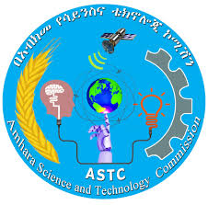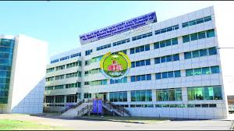

## **1.7: Service quality of a company**

### 1.7.1: Data center service

The Amhara Science and Technology Communication Commission is an important organization that focuses on promoting innovation and technological advancements in the Amhara region of Ethiopia. One of the key services provided by the Commission is assisting companies in establishing data centers. Data centers are essential for storing and managing large amounts of data, but building and maintaining them can be costly and time-consuming. By working with the Commission, companies can have access to data center facilities without needing to build them on their own private premises. This not only saves company’s money but also allows them to focus on their core business activities without having to worry about the complexities of managing a data center. Overall, the Amhara Science and Technology Communication Commission plays a crucial role in supporting businesses in the region and driving technological innovation forward.

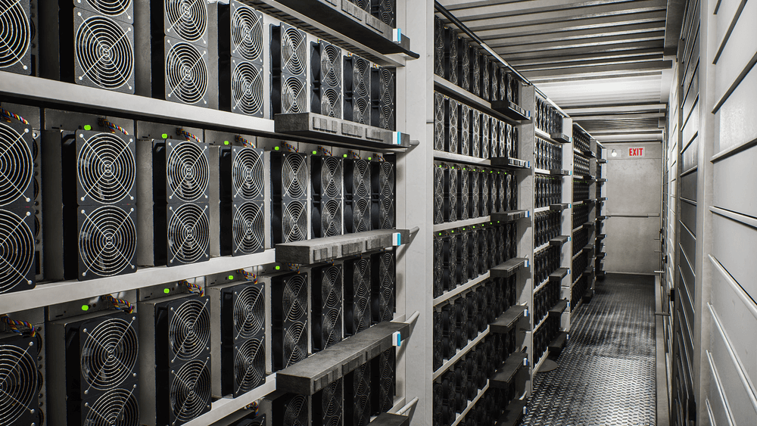

### **1.7.2: Web Based System**

The Amhara Science and Technology communication Commission has developed a web-site and software that assists companies in building data centers without the need to construct them on their own private premises. This innovative technology allows businesses to utilize data centers without the high costs and technical requirements of constructing and maintaining their own facilities. The Commission's web-site and software offer a streamlined and efficient solution for companies looking to enhance their data storage and processing capabilities. By utilizing this technology, businesses can focus on their core operations while benefiting from the advanced data center services provided by the Amhara Science and Technology communication Commission. It is a valuable resource for companies seeking to stay competitive in the digital age



### **1.7.3: Internship training service**

The Amhara Science and Technology communication Commission provides internship training services to assist companies in building data centers without the need to construct them on their private premises. This facility offers a valuable opportunity for companies to access the necessary resources and expertise to set up effective data centers, saving them time and money. By taking advantage of this internship training service, companies can focus on their core business activities while ensuring that their data infrastructure is secure and reliable. Overall, the Amhara Science and Technology Communication Commission plays a role in supporting the growth and development of businesses in the region by offering practical solutions to their technology needs.

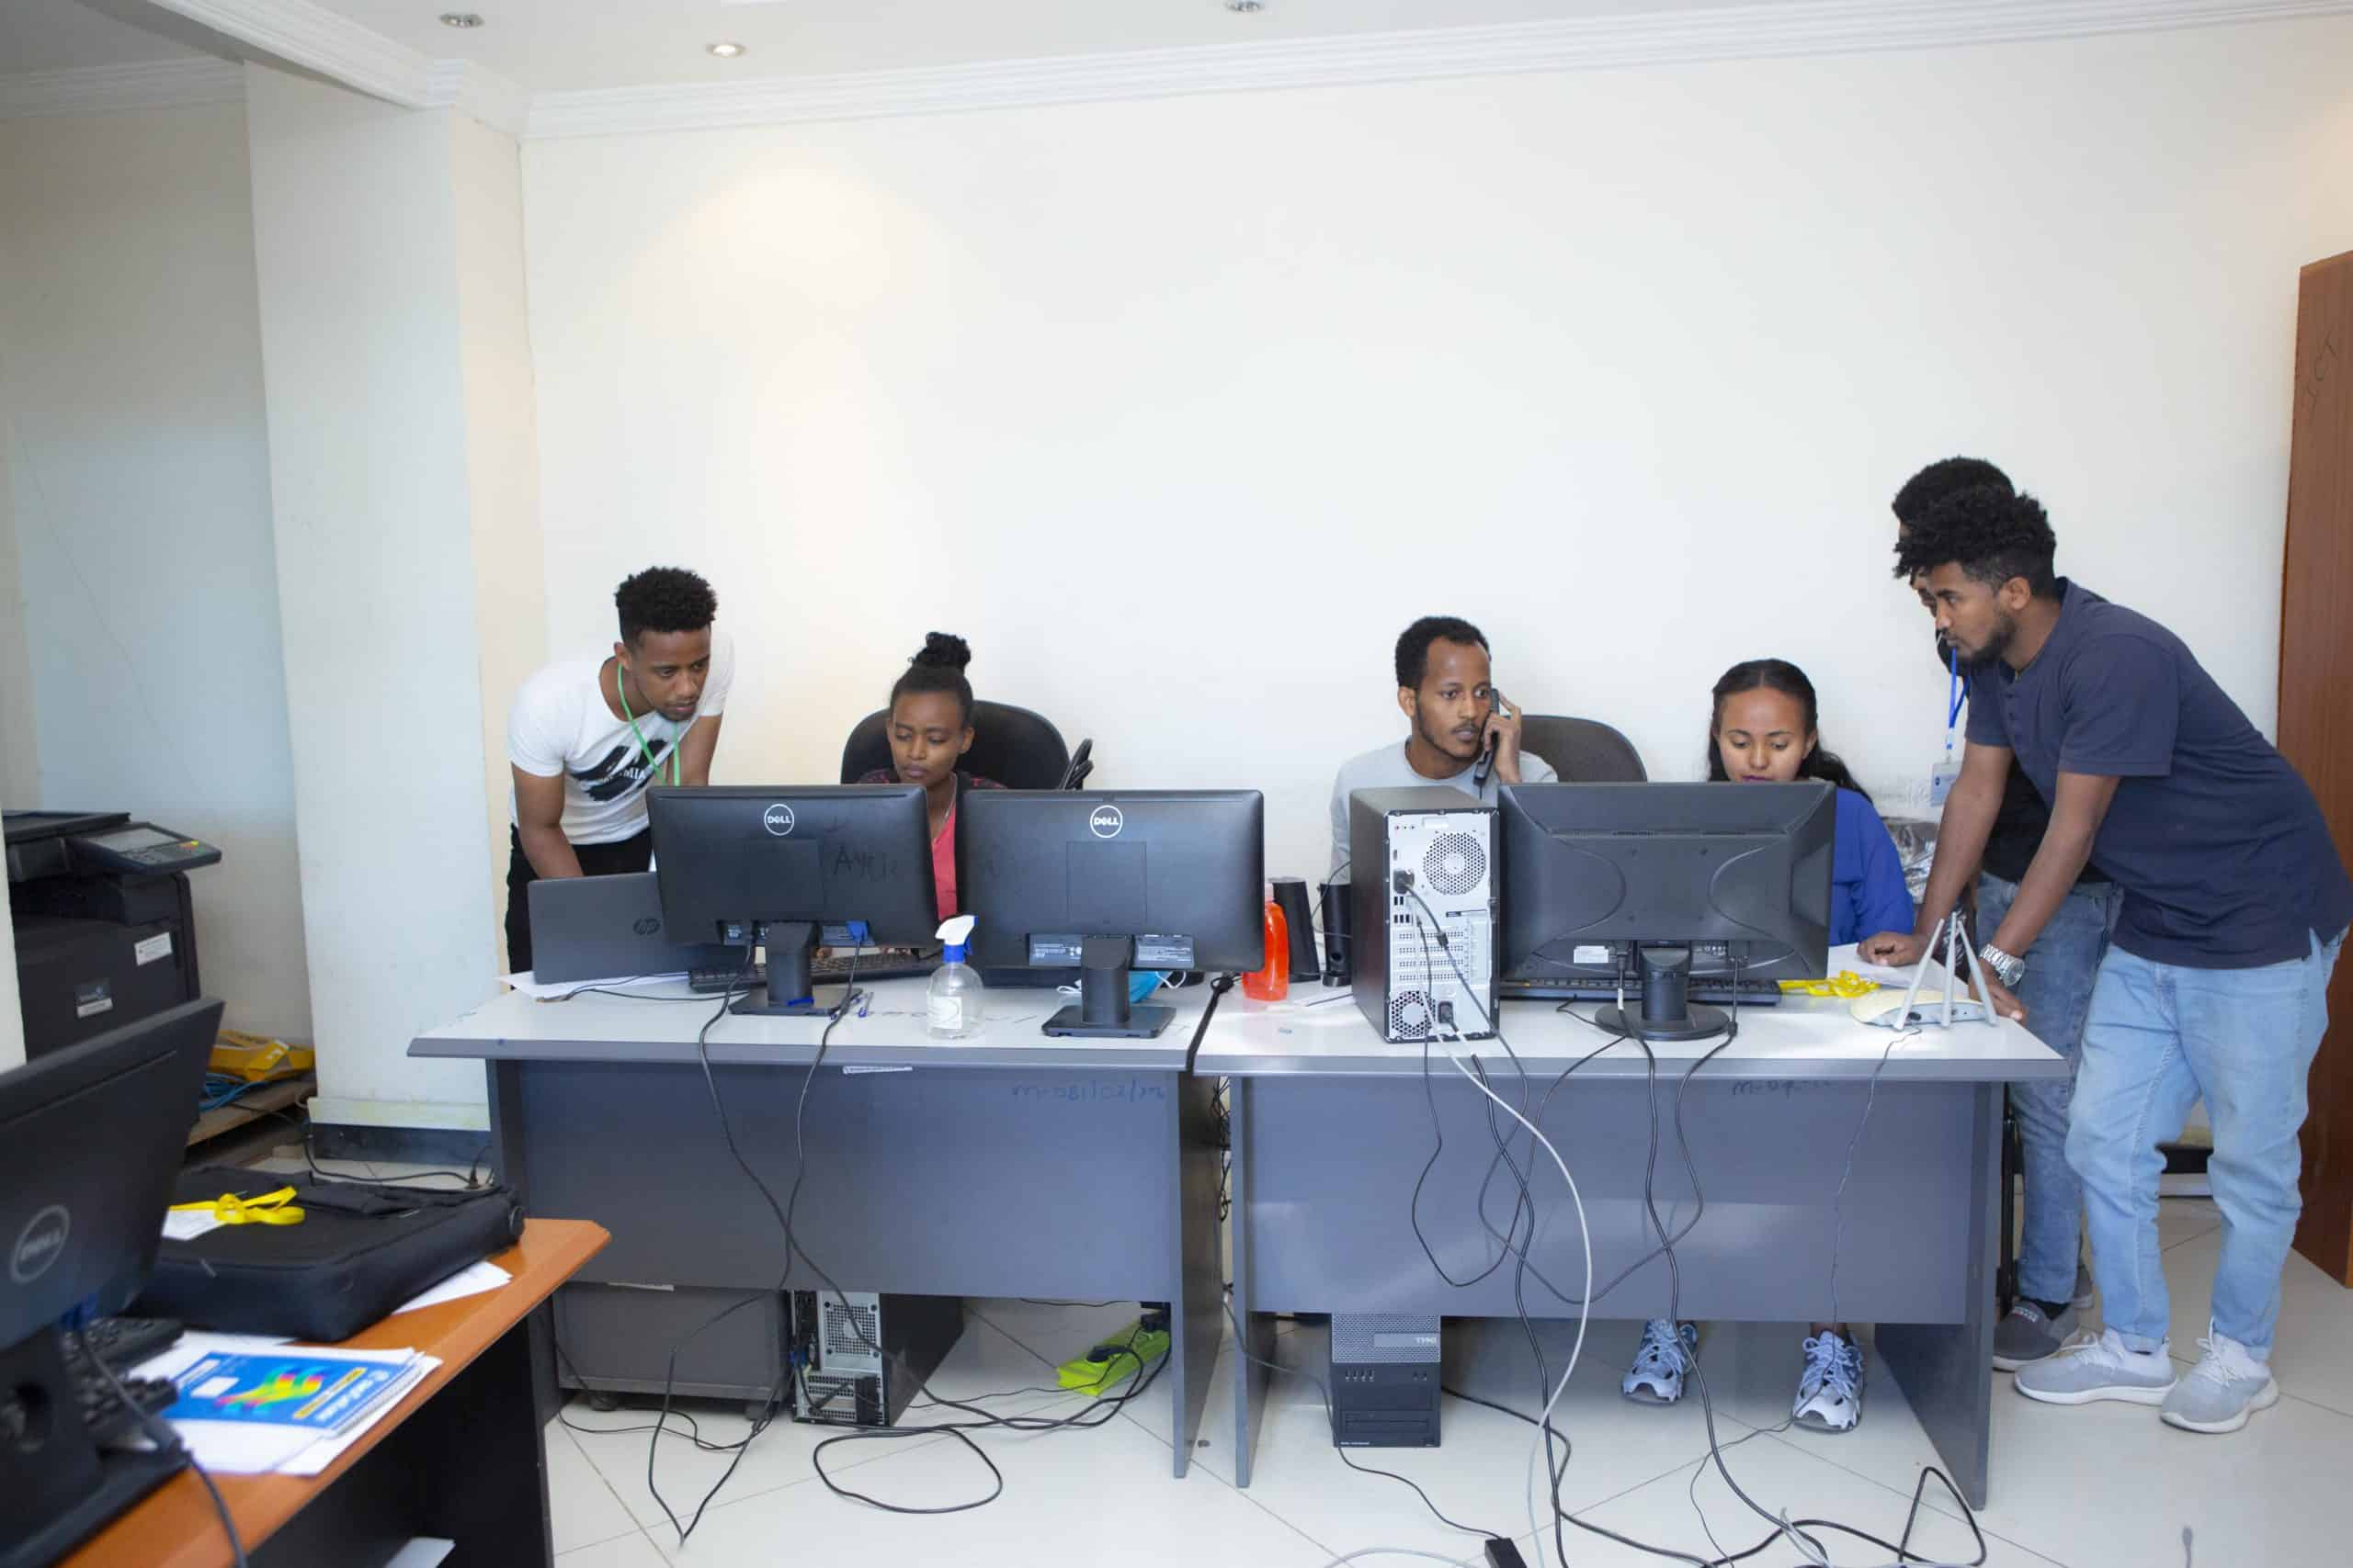

## **1.8: Organizational contacts**

* Bahir Dar, Ethiopia
* Telephone No. : 0582263759
* Gmail: [example@email.com](mailto:example@email.com)
* Postal : 2276
* Fax> :058-220-93-64
* For More Info. :[Sticc.gov.et](http://sticc.gov.et/)

## **1.9: Infrastructure of organization**

* Research and Development Facilities
* Collaboration with Universities and Research Institutions
* Networking and Capacity Building
* Innovation and Entrepreneurship Support
* Infrastructure Development Projects

### **1.9:1 Services of organization**

The Amhara Science and Technology Communication Commission is an organization that is dedicated to promoting and advancing scientific research and technological development in the Amhara region of Ethiopia. The Commission offers a variety of services to support these goals. Here are below points outlining some of the key services provided by the Amhara Science and Technology communication Commission:

* Research and Development
* Technology Transfer
* Capacity Building
* Science Education
* Innovation Grants
* Science Fairs
* Industry Partnerships
* Science Communication
* Scientific Networking
* Scientific Conferences
* Policy Development
* Technical Assistance
* Data Collection and Analysis
* Public Outreach

## **1.10: Objectives of organization**

The Amhara Science and Technology Communication Commission is an organization in Ethiopia that aims to promote and advance science and technology in the region. Here are ten objectives of the organization:

1. Foster research and development in various fields of science and technology within the Amhara region.
2. Support and fund innovative projects that have the potential to improve the lives of the people in the region
3. Collaborate with universities, research institutions, and industry partners to promote the exchange of knowledge and expertise.
4. Encourage young students to pursue careers in science and technology by providing scholarships and mentorship programs.
5. Establish partnerships with international organizations to access cutting-edge technology and expertise.
6. Organize workshops, seminars, and conferences to facilitate the sharing of knowledge and experiences among scientists and researchers.
7. Develop policies and strategies to address the challenges and opportunities in the field of science and technology in the region.
8. Promote the use of technology for sustainable development and environmental conservation.
9. Encourage the commercialization of research outcomes to boost economic growth and create job opportunities.
10. Monitor and evaluate the impact of science and technology initiatives in the region to ensure continuous improvement and effectiveness.

1.11: Organizational structure

## 

# **CHAPTER TWO**

# **INTERNSHIP EXPERIENCE**

## **2.1: Section of organization I were attend durq**mission, I had the opportunity to attend a section of the organization that focused on research and development. The section was filled with passionate engineers who were dedicated to finding innovative solutions to various challenges facing the region. I was able to witness firsthand the process of experimentation, data analysis, and collaboration that goes into developing new technologies and products. The atmosphere in the section was one of constant learning and discovery, with team members pushing each other to think outside the box and explore bold ideas. It was truly inspiring to be surrounded by such talented individuals who were working towards a common goal of advancing science and technology for the betterment of society. My time in this section taught me valuable lessons about the importance of curiosity, teamwork, and perseverance in the field of research and development.

## **2.2: Reason to select the organization**

I have decided to select the Amhara Science and Technology Communication Commission for my internship for various reasons.

* Focus on Scientific Research and Innovation
* Support for Local Development Initiatives
* Networking Opportunities with Professionals
* Contribution to Policy Development
* Skill Development through Diverse Projects
* Need to know about the system they used.
* Locally found

## **2.3: Organization network class**

As a Default-level student, I have been learning about the organization network class and devices used by the Amhara Science and Technology Communication Commission. This organization uses a variety of devices such as routers, switches, servers, and firewalls to create a secure and efficient network. Routers are used to connect different networks together, switches help to connect devices within the same network, servers store and manage data, and firewalls protect the network from unauthorized access. By utilizing these devices effectively, the Amhara Science and Technology Communication Commission is able to facilitate communication and collaboration among its members while also ensuring the security and integrity of its network. Overall, understanding the role of organization network class and devices is crucial for maintaining a successful and productive organization like the Amhara Science and Technology Communication Commission.

### **2.3.1: Routers devices**

Routers are devices used to connect different devices to the internet. The Amhara Science and Technology Communication Commission plays a crucial role in promoting the use of routers in the region. Routers help in establishing a secure and reliable connection for both individuals and businesses. With the help of routers, people can access the internet, communicate with others, and access valuable information. The Amhara Science and Technology Communication Commission educates people about the benefits of using routers and helps in spreading awareness about the importance of internet connectivity. By promoting the use of routers, the Commission is contributing to the development and progress of the region.



### **2.3.2: Switches devices**

Switches are devices that are used to control the flow of electricity in a circuit. They can be found in a variety of electronic devices, from simple light switches in our homes to more complex switches in computer networks. The ASTCC is an organization that focuses on promoting scientific research and development in the Amhara region of recognize the importance of switches in technology and are actively working to improve their efficiency and reliability. By investing in research and development, the Commission aims to bring cutting-edge technology to the people of Amhara, empowering them to be at the forefront of technological advancements. Switches may seem like a small component in a larger system, but they play a crucial role in how our electronic devices function.

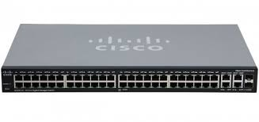

### **2.3.3: Server’s devices**

The ASTCC is an important organization in Ethiopia that focuses on promoting and advancing science and technology in the Amhara region. One key aspect of their work involves the use of server devices to support research and innovation in various fields. Servers are high-powered computers that store and manage data, allowing researchers and scientists to access and share information quickly and efficiently. By utilizing server devices, the ASTCC is able to facilitate collaboration among researchers, promote the development of new technologies, and support the growth of the region's science and technology sector. Overall, server devices play a crucial role in helping the Commission achieve its mission of advancing scientific knowledge and driving technological innovation in the Amhara region.

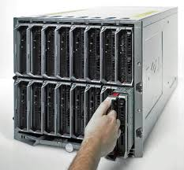

2.3.4 Firewall devices

Firewall devices are essential tools for protecting computer networks from potential threats. In the ASTCC firewall devices play a crucial role in safety guarding sensitive information and preventing unauthorized access to the network. These devices act as a barrier between a trusted internal network and untrusted external networks, filtering incoming and outgoing traffic based on a set of predetermined security rules. By monitoring and controlling network traffic, firewall devices help prevent malicious attacks such as viruses, melware, and hacking attempts. In addition, they also allow network administrators to set up access controls, manage bandwidth usage, and enforce security policies. Overall, firewall devices are vital components of a robust cybersecurity strategy and are essential for maintaining the integrity and confidentiality of network communications within the Amhara Science and Technology Communication Commission.

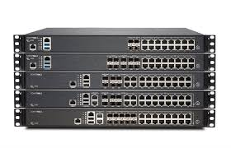

### **2.3.5: Fiber optic cable**

The organization network class of fiber optic cable at the ASTCC consists of a series of interconnected cables that are used to connect different departments and offices within the organization. This network allows for seamless communication and data transfer between employees, enabling them to collaborate more effectively on various projects and initiatives. One of the main advantages of fiber optic cable is its high bandwidth capacity, which allows for faster data transfer speeds compared to traditional copper cables. This means that employees at the ASTC can transfer large files, access online resources, and communicate with colleagues in real-time without experiencing any lag or delays. Additionally, fiber optic cable is also more reliable and secure than other types of cables, as it is difficult to tap into or intercept the data being transmitted. This provides peace of mind for the organization, knowing that their sensitive information and communications are safe from potential cyber threats.

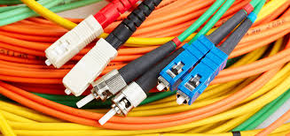

Fig: Fiber optic Cable

### **2.3.6: Access points**

The organization network class of access points at the ASTCC is designed to provide reliable and secure connectivity for all users. This network includes both wired and wireless access points, allowing users to connect to the internet from anywhere within the Commission's facilities. This flexibility is especially important for students and researchers who may need to work in different locations throughout the day. In addition to providing connectivity, the organization network class of access points at the Amhara Science and Technology Communication Commission also includes a range of resources and services to support users. For example, students and researchers can access online databases, e-books, and other digital resources through the network. They can also use the network to collaborate with peers, share files, and access online tools and software.



Figure : Access point

## **2.4 Network structure of organization**

The network structure of ASTC is designed to facilitate communication, collaboration, and information sharing among its various departments, research institutes, and partner organizations. This structure enables the organization to effectively coordinate its activities, pool resources, and leverage expertise to achieve its goals. At the core of ASTCC's network structure is the central coordinating body, which oversees the overall strategic direction and management of the organization. This body is responsible for setting priorities, allocating resources, and monitoring progress towards the achievement of ASTCC's mission and objectives.

In addition to the central coordinating body, ASTCC also includes several specialized departments and research institutes that focus on specific areas of science and technology. These units work together to conduct research, develop innovative technologies, and provide technical support and advice to government agencies, industry partners, and other stakeholders. Furthermore, maintains strong partnerships with academic institutions, industry associations, and international organizations to enhance its research capabilities and expand its reach. Through these collaborations, ASTCC is able to access additional funding, expertise, and resources that help to strengthen its programs and initiatives.

### **2.4.1: Configuration type**

Configuration is the process which is giving IP address for all network computers used in the system of organization.

An IP address is a numerical label that identifies each device on a network. Networking protocols use the address of each device to deliver network traffic to them. Each IP address must be unique.

Mainly there are two types of configuration. Those are;

**1. Static configuration**

**1. Static configuration**

A device with static IP addressing retains its IP address no matter how often it‘s rebooted or how long it‘s offline. The organization uses this type of configuration for printer.

**2. Dynamic configuration (DHCP)**

Dynamic IP address is one that’s automatically assigned to a device by a router. Computers and laptops are ‘t manufactured with IP addresses baked into them. The organization uses DHCP type configuration because it’s easy and effective type.

## **2.5 Operating system**

In the network structure of an organization, the operating system plays a crucial role in ensuring smooth communication and collaboration among the various devices connected to the network. An operating system is a software that manages hardware resources and provides a platform for running applications. In a network structure, the operating system helps in coordinating the activities of different devices such as computers, printers, servers, and mobile devices, allowing them to communicate and share information effectively. Additionally, the operating system ensures that data is securely transmitted and accessed within the network, protecting the organization's sensitive information from unauthorized access. Overall, the operating system is essential for the efficient functioning of a network structure in an organization, enabling seamless connectivity and communication among its various components.

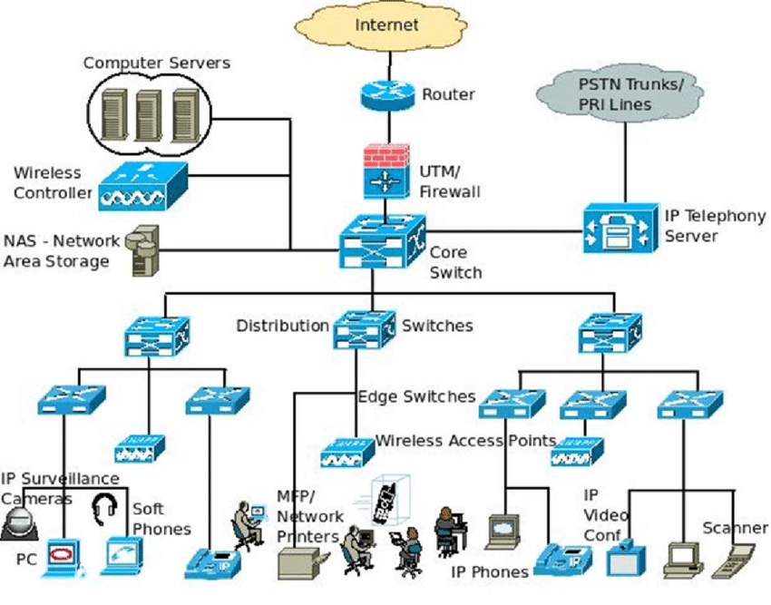

Fig: Organizational network Architecture

### **2.5.1: Types of operating system**

* One of the most popular operating systems is the **Windows operating system**, developed by Microsoft. It is widely used on personal computers and laptops around the world. Windows is known for its user-friendly interface and compatibility with a wide range of software and hardware. It offers various editions such as Windows 10 Home, Windows 10 Pro, and Windows 10 Education, each tailored to different user requirements.
* Another popular operating system is **MacOS** developed by Apple Inc. It is designed specifically for Apple's hardware, including Mac computers and laptops. MacOS is known for its sleek and intuitive interface, as well as its seamless integration with other Apple devices such as iPhones and iPads. It offers advanced features such as Siri voice assistant and iCloud storage, making it a favorite among creative professionals and tech enthusiasts.
* **Linux** is an open-source operating system that is favored by developers and tech enthusiasts for its flexibility and customization options. Linux comes in many distributions or "distros" such as Ubuntu, Fedora, and Debian, each offering a unique set of features and user interfaces. Linux is known for its security and stability, making it an ideal choice for servers and data centers.

### **2.5.2: Functions of the Operating System**

The operating system (OS) is a vital component of any computer system as it serves as the interface between the hardware and software applications. It is responsible for managing various system resources and ensuring smooth operation of the computer. Here are some essential functions of the operating system:

1. **Process management**: The OS manages processes running on the system, controls their execution, and allocates system resources to ensure efficient multitasking.
2. **Memory management**: The OS allocates and deallocates memory to running processes, ensuring that each process has enough memory to run efficiently.
3. **File system management**: The OS manages the file system, organizing and storing files on the storage devices, ensuring efficient access and retrieval of data.
4. **Device management**: The OS controls and manages input and output devices such as keyboards, mice, printers, and network interfaces for communication with external devices
5. **Security management**: The OS provides security features such as user authentication, access control, encryption, and firewall protection to safeguard the system from unauthorized access and malicious attacks.
6. **Resource allocation**: The OS allocates system resources such as CPU time, memory, and disk space to running processes based on priority and demand.
7. **Virtual memory management**: The OS uses virtual memory techniques to manage memory efficiently by swapping data between RAM and disk to optimize memory usage.
8. **Error detection and handling**: The OS detects and handles errors that occur during system operation, ensuring smooth functioning and preventing system crashes.
9. **System initialization**: The OS initializes the system hardware and software components during boot-up, loading essential system files and initializing drivers for devices.
10. **User interface management**: The OS provides a user-friendly interface for users to interact with the computer system, allowing them to control and manage system resources efficiently.
11. **Task scheduling**: The OS schedules tasks and processes to run at specific times, ensuring optimal utilization of system resources and preventing resource contention.
12. **Network management**: The OS manages network connections and communication between systems, facilitating sharing of resources and data transfer over networks.
13. **Power management**: The OS manages power consumption and battery life on devices such as laptops and mobile devices, optimizing power usage and extending battery life
14. **Backup and recovery**: The OS provides features for backing up and recovering data and system files, ensuring data integrity and system reliability in case of system failures.
15. **System performance monitoring**: The OS monitors system performance and resource usage, providing information on system health and performance metrics for optimization and troubleshooting.

### **2.5.3: Causes of the ‘Operating System Not Found’ Error**

The “Operating System Not Found” error is a common problem that many computer users encounter. This error message typically occurs when the computer is unable to locate the operating system that is needed to boot up the system. There are a variety of reasons why this error may occur, ranging from simple software glitches to more serious hardware issues. Based this the possible causes of the “Operating System Not Found” error.

* **Corrupted boot files**: One of the most common reasons for this error is corrupted boot files. If the files that are needed to boot up the operating system become damaged or corrupted, the computer may not be able to locate the necessary files to start up.
* **Hard drive failure**: A failing hard drive can also cause the “Operating System Not Found” error. If the hard drive fails, the computer may not be able to access the files needed to boot up the system.
* **Incorrect boot order**: Sometimes, the computer’s boot order may be set incorrectly, causing the operating system not to be found. This can typically be fixed by entering the computer’s BIOS and adjusting the boot order settings.
* **Missing operating system files**: If certain essential operating system files are missing or corrupted, the computer may not be able to boot up properly.
* **Virus or malware infection**: Viruses and malware can cause damage to operating system files, leading to the “Operating System Not Found” error.
* **Damaged Master Boot Record (MBR**): The Master Boot Record is a critical part of the boot process, and if it becomes damaged or corrupted, the computer may not be able to locate the operating system.
* **Upgrades or installations gone wrong**: If a recent operating system upgrade or software installation was not completed correctly, it can result in the operating system not being found during boot up.
* **Faulty hardware connections**: Loose or damaged hardware connections, such as with the hard drive or other internal components, can cause the operating system not to be found.
* **Incompatible hardware**: Installing new hardware that is incompatible with the current operating system can lead to the “Operating System Not Found” error.
* **Power failure during boot up**: A sudden power failure during the boot up process can cause the operating system to become corrupted, resulting in the error message.
* **Improper shutdown**: Shutting down the computer improperly, such as by holding the power button to force a shutdown, can lead to operating system file corruption.
* **Overheating**: Excessive heat can damage internal components, including the hard drive, leading to the “Operating System Not Found” error.
* **BIOS settings changed**: If the computer’s BIOS settings are changed incorrectly, it can result in the operating system not being found during boot up.
* **File system errors**: Errors in the file system, such as a corrupted file allocation table, can prevent the operating system from being located.
* **Software conflicts**: Conflicts between different software applications or drivers can also lead to the “Operating System Not Found” error.

## **2.6: Activities that I have done in internship program**

* Research and data collection
* Network installation
* Attending workshops and training
* Assisting with experiments and projects
* Writing reports and documentation
* Creating presentations
* Participating in brainstorming sessions
* Conducting surveys and interviews
* Networking with professionals
* Attending conferences and seminars

## **2.7 Challenges I faced during internship**

The internship period was interesting in many ways but in some case there are different challenges what I faced in the organization. Like;

* Since the internship was at the end of fiscal year they spent a lot of time on inventory.
* Lack of attention due to the organization haven ‘t regular program for internship
* National problem of peace
* Lack of internet.
* Limitation of hardware equipment like desktop

## **2.8: Solution for the challenges**

* Use hardware materials in shift
* Use break time to observe and discuss with them.

# **CHAPTER THREE**

# **INTERNSHIP PROJECT**

## **3.1: Introduction**

The internship report on the Amhara Science and Technology Communication Commission provides a comprehensive overview of the organization's programs and initiatives aimed at promoting scientific research, technological innovation, and sustainable development in the Amhara region of Ethiopia. Through our internship experience, we had the opportunity to gain firsthand knowledge of the Commission's efforts to leverage science and technology to address pressing socio-economic challenges facing the region. This report will delve into the various projects and activities we were involved in during our time at the Commission, highlighting the impact of these initiatives on local communities and the broader development landscape in Amhara. We hope that this report will serve as a valuable resource for stakeholders interested in learning more about the Commission's work and the potential for science and technology to drive positive change in the region.

## **3.2: Statement of the problem**

The ASTCC currently lack us an integrated and efficient system to manage its employees leading to several operational challenges. existing methods for handling employee-related processes are manual, fragmented, high budget required for resource, and prone to errors, which impacts overall productivity and staff satisfaction. Specifically, the issues include:

* **Inadequate Performance Tracking:** There is no centralized mechanism for monitoring employee performance, which makes it difficult to set goals, track progress, and provide timely feedback and development opportunities.
* **Fragmented Data Management:** Employee information is stored across multiple platforms or manually, resulting in difficulties in accessing, updating, and maintaining accurate records.
* **Lack of Integration with Other Systems:** The absence of integration with other business systems (e.g., payroll, project management) creates inefficiencies and data silos, leading to redundant data entry and increased risk of errors.
* **Challenges in Compliance and Reporting:** Ensuring compliance with legal and regulatory requirements is cumbersome due to the lack of automated reporting tools and real-time data access.
* **Performance Evaluation Challenges:** The absence of a structured performance management system makes it difficult to conduct regular evaluations. This lack of formalized feedback can lead to employee dissatisfaction and hinder professional development.
* **Leave and Attendance Management Issues:** Managing employee leave requests manually is time-consuming and prone to errors. This can result in miscommunication regarding employee availability, affecting project timelines and team productivity.
* **Limited Communication Channels:** Current communication methods are inefficient, leading to misunderstandings and a lack of engagement among employees. Important updates and feedback do not reach all employees in a timely manner.
* **Regulatory Compliance Risks:** Maintaining compliance with labor laws and internal policies is challenging without a centralized system that tracks necessary documentation and reporting requirements.

To address these challenges, the ASTCC needs a comprehensive Employee Management System that streamlines recruitment, performance management, data handling, and compliance, ultimately enhancing operational efficiency, data accuracy, and employee satisfaction.

## **3.3: Objective of the project**

The objective of this project is to develop online employee management system (OEMS) for ASTCC and the project has the following general and specific objectives.

### **3.3.1: General objective**

The general objective of the project is to develop online project employee management system for ASTCC.

### **3.3.2: Specific objectives**

The following are the specific objective of online project employee management system:

* To identify problem of the current existing system.
* To gather different information that will help us in building our system.
* To develop user friendly interface.
* To build database that will record different employee information permanently.
* To design of the proposed system based on the development requirement of the organization infrastructure.
* To build system that will decrease the work load of the HR departments and others.
* To Implement the system based on the design.
* To Test the system and verify that all the required functionalities are implemented.
* To deploy the system in the working environment.

These specific objectives aim to improve the efficiency and effectiveness of HR operations, support employee engagement, and contribute to the organization's overall success.

## **3.4: Beneficiary of employee management system**

The beneficiaries of an Employee Management System (EMS) like ASTCC (assuming ASTCC refers to a specific organization or system) typically include various stakeholders within an organization. Here are the primary beneficiaries:

* **Employees:** -Self-Service Access: Employees can access their personal information, pay stubs, and benefits online.
  + Performance Tracking: They can track their performance and receive feedback more easily.
  + Training and Development: Access to training resources and career development opportunities.
* **HR Department:** -Streamlined Processes: Automates administrative tasks such as recruitment, onboarding, and payroll management.
  + Data Management: Centralizes employee data for easy access and reporting.
  + Compliance: Helps ensure compliance with labor laws and regulations.
* **Management:** -Performance Insights: Provides analytics on employee performance and productivity.
  + Resource Allocation: Aids in effective workforce planning and resource allocation.
  + Decision-Making: Facilitates informed decision-making based on real-time data.
* **IT Department:** -System Integration: Simplifies integration with other systems (e.g., payroll, finance).
  + Data Security: Ensures that employee data is stored securely and complies with data protection regulations.
* **Finance Department:** -Cost Management: Helps in managing payroll and benefits more efficiently, leading to better financial planning.
  + Budgeting: Provides insights into labor costs for budgeting purposes.
* **Organizational Culture:** -Improved Communication: Enhances communication between employees and management, fostering a positive work environment.
  + Employee Engagement: -Tools for feedback and recognition can boost morale and engagement.

## **3.5: Significant of the project**

some of the significance of an Employee Management System (EMS):

* **Improved Efficiency:** An EMS automates many administrative tasks, freeing up HR and management to focus on more strategic activities.
* **Enhanced Accuracy:** Automated processes reduce errors and ensure that employee data is accurate and up-to-date.
* **IncreasImproved Employee Experience:** **ed Productivity:** By streamlining processes and reducing manual errors, an EMS helps employees to be more productive and focused on their core responsibilities.
* **Better Decision Making:** An EMS provides real-time data and analytics, enabling managers to make informed decisions about employee performance, training, and development.
* **Improved Employee Experience:** An EMS helps to create a positive employee experience by providing easy access to information, facilitating communication, and enabling employees to manage their own data.
* **Compliance and Risk Management:** An EMS helps organizations to comply with labor laws and regulations,
* **Improved Employee Experience:** **:** solution, or approach that provides good value for the money spent. It means achieving the desired results or benefits without incurring unnecessary expenses. A cost-effective solution maximizes efficiency and effectiveness while minimizing costs, ensuring that resources are used wisely.

## **3.6: Scope and limitations of project**

* Recruitment and Onboarding
  + - Job posting and application tracking
    - Candidate screening and selection
    - Onboarding and orientation processes
* Performance Management
  + - Goal setting and performance tracking
    - Regular performance evaluations and appraisals and improvement plans
* Attendance and Leave Management
  + - Time and attendance tracking
    - Leave requests and approvals
    - Absenteeism monitoring and reporting
* Payroll and Benefits Administration
  + - Salary calculations and payroll processing
    - Benefits enrollment and management
    - Tax deductions and compliance
* Employee Records Management
  + - Centralized storage of employee information Management of personal details, work history, and qualifications
    - Secure access and data protection

* Training and Development
  + - Identification of training needs and opportunities
    - Management of training programs and sessions Tracking of employee development and career progression
* Compliance and Reporting
* Adherence to labor laws and regulations
  + - Generation of compliance reports and documentation Monitoring of legal and regulatory changes Communication and Collaboration.
* Internal communication tools
  + - Collaboration features for team projects and tasks
* Employee engagement and feedback mechanisms
* Analytics and Reporting

## **3.7: Feasibility of study of project**

A feasibility study involves evaluating various aspects to determine whether the system is viable and beneficial. Here’s a structured approach to conducting this study:

* **Technical Feasibility:**

Our system developed by using technological system development techniques such as HTML, Java script, CSS and XAMP database server without any problems and the group members have enough capability to develop the project. The implementation of security measures safeguards user data, addressing technical concerns related to data integrity and confidentiality.

* **Economic Feasibility**

The project demonstrates feasibility through its cost-free access to essential features for users.Since this project will computerizes the existing system, by now the reduction of cost for materials used in manual operation.

* **Operational Feasibility** 
  + User Acceptance: Evaluate the likelihood of successful adoption by employees and HR staff, considering their readiness for change and training needs.
  + Process Impact: Analyze how the EMS will affect current HR processes and workflows, and identify any necessary adjustments.
  + Support and Maintenance: Assess the availability of technical support and maintenance services, and ensure that the system can be effectively managed.
* **Legal and Compliance Feasibility**

The system will not have any conflict with the rule and regulation of country and also it is legally acceptable since it respects other constitutional laws of the country.

* Risk Assessment
  + Identify Risks: Identify potential risks associated with the implementation, such as technical issues, resistance to change, or data migration problems.
  + Mitigation Strategies: Develop strategies to mitigate identified risks and address potential challenges.

## **3.8: Methodology of project**

### 3.8.1: Data gathering methods

**Interview:**

Interviews were the first of the methods we used to collect data. We meet with HR departments to find out what they do.

How do they work?

How the system you are currently using works ; We asked.

And now we know that there is no system that they are using and they are using it manually.

**Observation:**

We have seen that they are having difficulty in finding the required file because they are using manual to retrieve the file in the human resources office.

**Document analysis:**

We have collected information about projects that have been done in the past, as well as information that can be used for the project that we intend to do on the Internet.

**SDLC Model**

We believe that the biggest strength of the iterative model is its ability to handle uncertainty and incorporate change into the project’s DNA. Apart from that, its strong points involve:

* quick decision making through constant communication;
* fast and regular delivery of a piece of working software meaning that results are obtained early and periodically;
* early release of a working product;
* an easier and cheaper way to make changes in project requirements;
* feedback from the client and users at an early stage and throughout the whole development life cycle;
* a better way to test and fix small pieces of software;
* the end-users being less overwhelmed since the product gets more complex gradually; and
* The ability to develop a more complete and valuable product.

### **3.8.2: Development tools**

**Hardware tools**

* Laptop – to do any activity of project
* Desktop –
* Mobile phone –
* USB flash – for storage purpose, 32GB
* Stationary materials – for collecting data and others

**Software tools**

* MS word – for writing document and proposal
* Visual studio code – for creating front end of the project/ user interface
* XAMP – for database connectivity
* Browser – for running the HTML code
* Window 10

## **3.9: Build database system**

To ensure that the database is accurate, secure, and easy to use, it is important to follow a series of steps to build it effectively. Below, I will outline the steps involved in creating a database for recording employee information permanently.

Figure

Step 1. Define the purpose and scope of the database: Before creating the database, it is essential to determine its purpose and scope. This involves identifying the specific information that needs to be recorded for each employee, such as their name, contact information, job title, department, and any other relevant details. By clearly defining the purpose and scope of the database, you can ensure that it meets the needs of the organization and its employees.

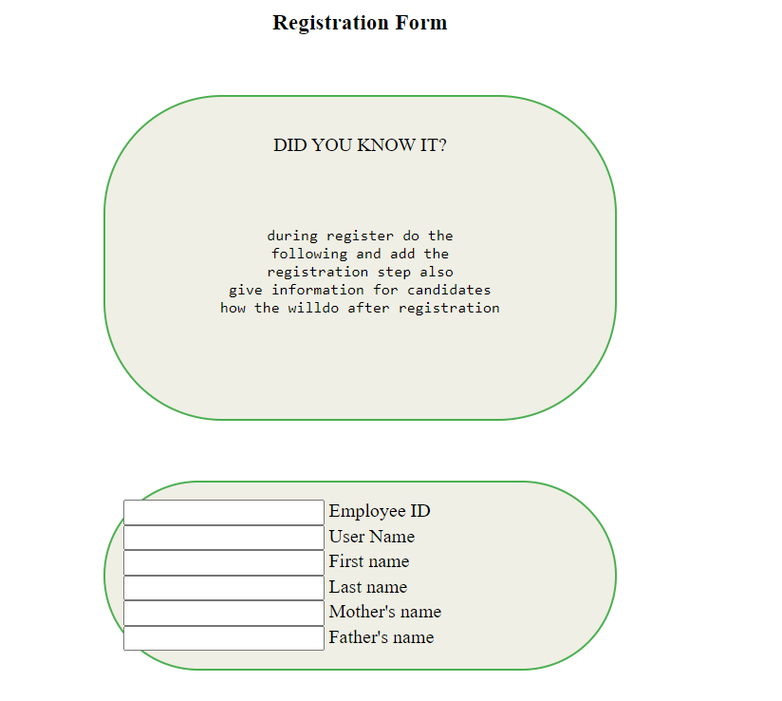

Step 2 Create the database tables: Once the database schema has been designed, the next step is to create the database tables based on the schema. Each table should correspond to a specific entity in the organization, such as employees, ademine logine, or registre. It is with create tables

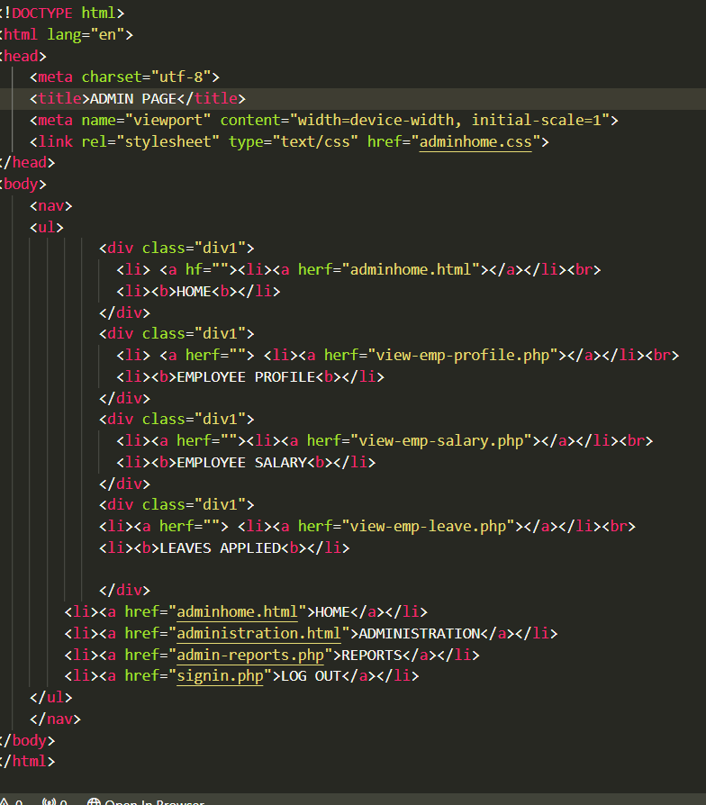

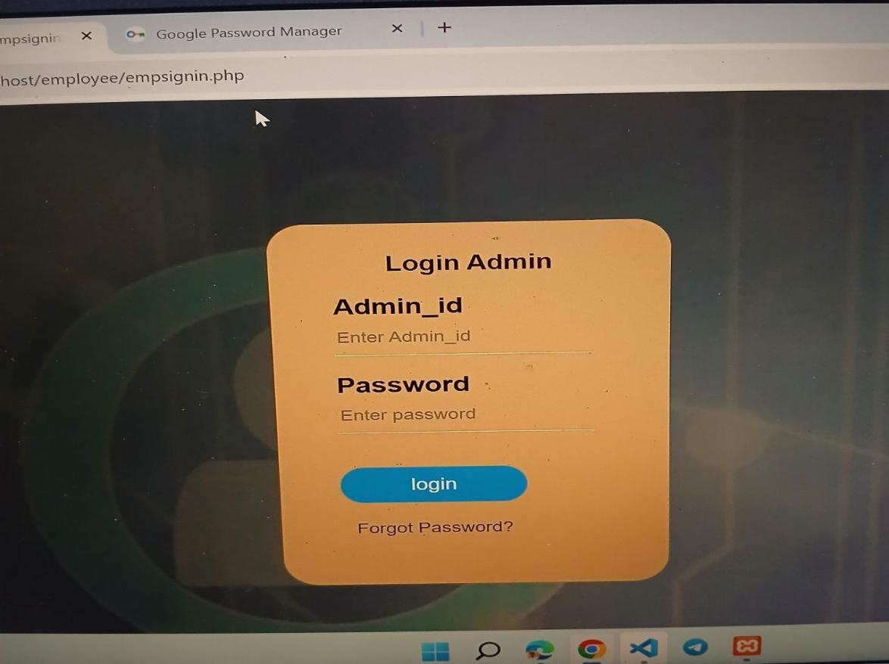

Step 3. Input employee data: After creating the database tables, the next step is to input employee data into the database. This can be done manually by entering the information directly into the database or by importing existing data from spreadsheets or other sources. It is important to ensure that the data is accurate and up-to-date to provide a reliable record of employee information.

Figure

# **CHAPTER FOUR**

# **BENEFITS GAINED FROM INTERNSHIP**

## **4.1: Introduction**

In the period of internship program, I gain many benefits. Some of these are listed below:

* Theoretical and practical knowledge
* Helps to develop and update knowledge
* Helps to think out of box
* Helps to get communication and
* leadership skill for future

## **4.2: Theoretical knowledge**

* System Design
* Document writing

## **4.3: Practical knowledge**

* Practical system design
* Responsibility
* Patience
* Time management
* Reading skill
* Motivation skill

## **4.4: Leadership skill**

* Creativity
* Employee management
* Time management
* Open communication
* Employee handling

## **4.5: Interpersonal communication skill**

Interpersonal communication skill is an essential skill and important type of skill to be exercised in daily life in order to communicate with others. In the internship period I get good interpersonal communication skill from the organization employees.

# **CHAPTER FIVE**

# **CONCLUSION AND RECOMMENDATION**

## **5.1 Conclusion**

During my internship period, I had a short but very interesting experience. Despite facing some challenges that cut my time short, I still found the program to be incredibly valuable. It provided me with the opportunity to apply the knowledge I had learned in the classroom to real-world situations, which helped me to better understand and appreciate the concepts I had been studying. Additionally, I was able to observe and analyze how the organization operated, gaining insights that I would not have been able to acquire otherwise. Overall, the internship program was a crucial step in my learning journey, as it not only broadened my understanding of the department I was working in but also gave me valuable insights into life in general. I am grateful for the experience and look forward to applying what I have learned in future endeavors.

## **5.2 Recommendation**

Even if the internship program was important and interesting, I would like to list some recommendations for the organization, university and for students.

### **5.2.1 Recommendation for the organization**

* For next focus the internship program students and give regular time to exercise
* Add additional practice for internship program students as like employees.
* Accept more students and learn more in this organization.

### **5.2.2 Recommendation for university**

* Set normal schedule for internship program as like other courses
* Answer the students question properly on time
* Contact organizations those have pleasure to accept students in that area

### **5.2.3 Recommendation for students**

Find out local organization for internship program

Attend and exercise all experience of the given internship program

Be punctual and honest for their internship

5.3 References

- Departement of HR interview

- Refer other project and documentation

- Google,YouTube video

*THANK YOU*